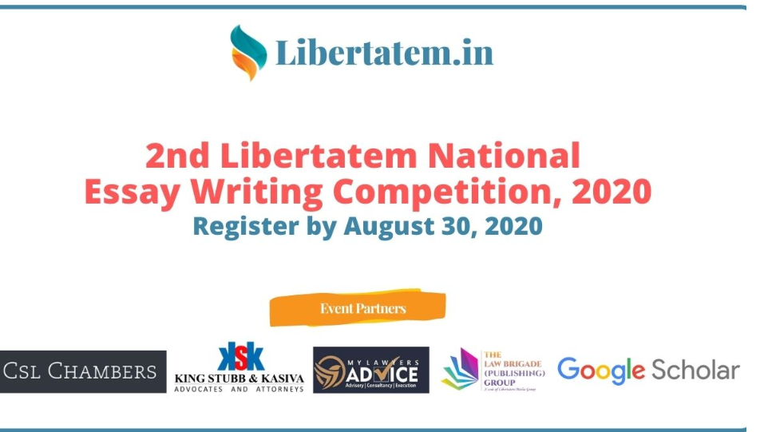

About the Organizer of 2nd Libertatem National Essay Writing Competition
Libertatem Magazine is an e-Magazine published online focusing on Legal, Political & Economic News and Courtroom Updates. It is an online-platform with a diverse readership of over a million readers ranging from Students, Academics, Legal Professionals to Legal Enthusiast and many more. With our Monthly Digital Magazine and Daily Updates on current and pressing legal issues, our aim is to help the legal community expand its outreach and more importantly express their views on the same uncensored. Since February 2015, we have been working tirelessly on our mission to engage and aware our citizens of the legal angle in our news stories and courtroom updates which are commonly ignored by large media houses in order to gain readership using “sensational” stories.

Law Firm Partners

ABOUT CSL CHAMBERS
CSL Chambers is a boutique law firm based in New Delhi, India with global capabilities through its close association with Clyde & Co. The firm thrives on its global capabilities through its close association with Clyde & Co, a full-service international law firm with over 50 offices worldwide.
CSL Chambers focuses on providing innovative legal solutions and adroitly resolving complex issues in line with the client’s commercial interests. The firm takes pride in understanding clients’ pressures, considerations, and businesses in line with their legal needs, thereby, providing sound strategic solutions based on the rapidly changing trade and commerce activities.

ABOUT KING STUBB AND KASIVA ADVOCATES & ATTORNEYS (KSK)
KSK represents a large number of Indian business houses, multinational corporations, banking & financial institutions, small, medium & large Indian and International companies and start-ups across the country.
KSK has offices in New Delhi, Mumbai, Bangalore, Chennai, Hyderabad and Kochi. KSK has alliances with associate lawyers across all the 29 states and 7 union territories in India and we are able to cater to all legal requirements of our clients across the length and breadth of the country. KSK also has a huge informal network of International law firms across 97 countries. This network of alliances gives the benefit to the clients of a single-window service provider, to deal with all kinds of matters across the country under one umbrella.

Knowledge Partner

ABOUT MY LAWYERS ADVICE
My Lawyers Advice is a full-service boutique web-based online platform which is a unique and one of its kind venture started by a group of highly qualified, meticulously skilled and professionally trained group of Advocates and Lawyers in Delhi-NCR, India. The same is a clear departure from the primitive and traditional system where an Individual or a Corporate has to travel and wait for long in order to avail and obtain professional legal services, however, with the advent of the e-age time has come when the professional legal services are just a click away traveling beyond the barriers of distance and time which ultimately helps in the resolution of the issue in hand without any hassles and without any wastage of resources.

Publication Partner

ABOUT THE LAW BRIGADE PUBLISHERS
The Law Brigade Group is an online, open-access journal publisher. The Law Brigade enjoys the position of being India’s Largest Journal Publisher having a portfolio of 9 International Law Journals. Out of 9, 2 Journals operated by them are indexed in the prestigious Google Scholar and enjoy one of the highest Impact Factor in the Industry. They publish valid primary research from all areas of the Law. You can visit thelawbrigade.com to find out all journals published by The Law Brigade Group. The Law Brigade Group’s Editorial Advisory Panel and Editorial Board spans the spectrum of Law and is at the heart of what they do. The Law Brigade Group is a fully open access journal publisher.

ABOUT THE 2ND LIBERTATEM MAGAZINE ESSAY WRITING COMPETITION
Based on the Media Group’s vision to engage and aware people around us, we continuously bring in engaging news stories and courtroom updates which are both informative as well as essential for every common person out there.
We believe the people we are surrounded with have a lot to express than just criticize everything that happens. We have a strong belief that everyone has his/her own perspective and sound reasoning behind every criticism they have. We, at Libertatem Magazine, strive to unleash that inner belief and encourage people to put their opinions and views on the table where they can be discussed freely. That is where Libertatem comes in. We have named this magazine as Libertatem Magazine as the main concept of the Magazine is “Freedom of Speech & Expression”. We respect everyone’s right to speak.
With this line of thought, we have gearing up to organize a series of Essay Writing Competitions wherein everyone be it a student or otherwise, be it from Law or from non-Law, everyone is free to express their views/ opinions on a given theme.

SUGGESTED THEME & SUB-THEMES FOR THE ESSAY COMPETITION

Theme 1: Coronavirus and its Impact
Sub Themes:
- COVID-19: Impact on Commercial Contracts
- COVID-19: What Legal Rights of yours are In a Quarantine
- COVID-19 and the Public Health Care System in India
- Impact of Lockdown on Migrant Workers
- COVID-19 and its Impact on Mental Health
- Epidemic Diseases Act, 1897: Its Use and Relevance Today
- COVID-19 and the Role of Social Media
- The Migrant labour crisis before and after COVID 19
- Corona treatment: A distant dream for the poor
- India fights the pandemic with a British Era Act: Should new laws be implemented or not?
- The Arogya Setu app and its effectiveness
- Is the pandemic taking away the career of millions as it is taking the lives?
- COVID-19 Pandemic: a chance for new world order?
- Has COVID crisis pushed India to the 4th Industrial Revolution?
- Post-Covid economic recovery and sustainable development goals: Can they go hand in hand?
Theme 2: Political & Social Developments
Sub-Themes:
- Ban on Chinese Apps: Fair or unfair?
- Nepotism and its Global Presence
- Custodial Death: A threat to rule of law
- PM Cares fund: Need, Scheme, and concerns
- Ayodhya Dispute: A battle between faith and rationality?
- Ram Mandir Inauguration and the Indian Media
- Palghar Incident: The constitutionality and criminality of mob lynching
- New Education Policy- A real masterstroke?
- New Education Policy & the Kendriya Vidhyalaya’s Opposing
- EIA Report 2020: Boon or a Bane to the environment?
- India’s World Solar Bank Initiative
- Permanent Commission for women in the Army
- Chief Justice of India: Strict observance of ethics or a personal life with choices
- India and its Cyber Policing
- Hike in taxes and petrol prices
- Effectiveness of ASMITA scheme for the distribution of Sanitary Napkins
- Deliberate or Non-Deliberate Ignorance: Northeastern states not a part of India in times of crisis?
- The Discriminative Internet: Is it the best alternative for the poor to educate their children?
- How effective is the Anti-Defection Law?
- Can RTI truly eradicate corruption?
- Three language policy as A part of the National Education Policy: Is this ideal?
- A year on, Article 370 and Kashmir mythmaking
- Media Independence and its reporting
Mentioned above are just broad themes and the participants are expected to work on any one of these or they can also write on theme/topic related to the above-mentioned theme.

ELIGIBILITY
- We look forward to participation from any students (Certifications/ Diploma/ UG/ PG) from any stream from any Universities/ Colleges/ Institute in India.
- Multiple entries from one participant are not permitted.
- Co-Authorship is not permitted.

SUBMISSION GUIDELINES
- The essay must be written solely by the candidate, in English, and may not have been submitted for publication elsewhere.
- Authors should not mention their names or any kind of identification mark in the manuscript. Any manuscript found to have any details of authors shall be rejected.
- The essay shall not exceed 2000 words (excluding footnotes). The minimum word limit is 1,000 words.
- All submissions have to be made in MS Word format and should be typed in Times New Roman, Font Size 12 and 1.5 Line Space.
- Footnotes should follow the Bluebook 20th Edition and shall be typed in Times New Roman, Font Size 10, and 1 Line Space.
- The Page Margins should be 1” or 2.54 cm on all sides.
- All text should be aligned as Justified.
- All the claims of the authors, in the body of the manuscript, are expected to be backed by reasons along with proper citations and shall not be merely an assertion.
- Submission should also mandatorily include the author’s view, in the conclusion, taking into consideration the aspects/contentions discussed throughout the manuscript.
- Any violation of rules shall result in direct disqualification.
- The essays will be scrutinized through plagiarism software. Only original essays will be considered for the competition. No part of it should have been published earlier nor should it be under consideration for publication or a contest elsewhere. Moreover, any form of plagiarism will result in the disqualification of the essay.

EVALUATION CRITERIA & WEIGHTAGE
- Understanding of Issues (20 Marks)
  - Does the essay demonstrate an understanding of the relevant legal issues?
  - The individuality of perspectives:
  - Does the essay show evidence of independent thinking on the part of the author(s)?
- Quality of Analysis (20 Marks)
  - Are the principle questions raised in the essay justified?
  - Are the arguments logical and persuasive?
  - Have counterclaims been considered?
  - Are the assumptions of the essay if made, justified and proper?
- Quality of Research (20 Marks)
  - Good
  - Average
  - Poor
- Formatting & Language (20 Marks)
  - Is the essay properly formatted?
  - Are the footnotes according to the Bluebook 20th Edition?
  - Are there any grammatical or spelling mistakes?
- Suggestions & Recommendations (20 Marks)
  - Whether an appropriate solution or recommendation is made out at the end of the essay.

COPYRIGHT OF THE SUBMISSION
- All the essays submitted shall be the exclusive property of Organisers.
- Organizers shall be free to use the information/ views therein in any manner it requires.
- No essay shall be entertained if received after the deadline.
- The decision of Organisers in deciding the winner(s) shall be final and binding and no query, correspondence, etc. in this regard shall be entertained by the Organisers.
- Laws of India with the jurisdiction of courts at Ahmedabad shall apply to this competition.

Note:
- Essays incompatible with the above rules and submission guidelines will not be considered.
- The submission of entries to the competition implies acceptance of the above terms and conditions by the participant(s).

REGISTRATION & SUBMISSION PROCEDURE
- Participants would require to register for the 2nd Essay Writing Competition by Paying the Registration Fee on the website. (Link Mentioned Below)
- Once the Registration Fee is paid, participants should take a screenshot or picture of the same and fill the Registration Form.
- After you fill-up the registration form, you would receive an acknowledgment email from our end. The Registration part will be over after this step. You will now be required to submit your essay before the deadline.
- Participants would have to submit their essays using the Submission Form on the Website. (Link Mentioned Below)
- The participants would have to submit their essay the latest by 11:59 PM, August 25, 2020, after which the submission form will close.
- After submitting your essay, you will receive an automated essay submission acknowledgment email from our end.

LINKS
- Payment & Registration Page: https://libertatem.in/register/
- Submission of Essay: https://libertatem.in/competition-submission-form/

IMPORTANT DATES
Registration Opens: August 10, 2020
Registration Ends: August 30, 2020
Submission Deadline: September 5, 2020
Declaration of Result: September 10, 2020

REGISTRATION FEES
The participants are expected to register for the 2nd Libertatem Essay Writing Competition by paying the registration fee of Rs. 400 before the Registration Deadline i.e. August 30, 2020

MODE OF PAYMENT
Registration Fee should be paid via our
- Payment Gateway using Credit Card/ Debit Card/ Net Banking/ UPI or Wallet Services.
- Direct UPI Payment using the QR Code

PROCEDURE FOR REGISTRATION
- Participants need to Register by paying the Registration Fee of Rs. 400 using the above-mentioned payment modes
- Participants will then have time till September 5, 2020 for submission of their Essay.
- Once a Participation is confirmed, there shall be no cancellation or refund.

PRIZES:
1st Position/ Winner:
- 3,000 Cash Prize
- 1 Month Internship with CSL Chambers, Delhi (Unpaid, Post Lockdown)*
- 1 Month Work From Home Internship with King Stubb & Kasiva (Unpaid)
- 1 Month Work From Home Research Internship with K&S Legal (Unpaid)
- Publication of essay in Google Scholar Indexed Journal by thelawbrigade.com
- E-Certificate of Publication
- E-Certificate of Achievement
2nd Position/ First Runner Up:
- 2,000 Cash Prize
- 1 Month Internship with CSL Chambers, Delhi (Unpaid, Post Lockdown)*
- 1 Month Work From Home Internship with King Stubb & Kasiva (Unpaid)
- 1 Month Work From Home Research Internship with K&S Legal (Unpaid)
- Publication of essay in Google Scholar Indexed Journal by thelawbrigade.com
- E-Certificate of Merit
- E-Certificate of Publication
- E-Certificate of Participation
3rd Position/ Second Runner Up:
- 1,000 Cash Prize
- 1 Month Internship with CSL Chambers, Delhi (Unpaid, Post Lockdown)*
- 1 Month Work From Home Internship with King Stubb & Kasiva (Unpaid)
- 1 Month Work From Home Research Internship with K&S Legal (Unpaid)
- Publication of essay in Google Scholar Indexed Journal by thelawbrigade.com
- E-Certificate of Publication
- E-Certificate of Participation
- E-Certificate of Merit
4th Position to 10th Position
- 4th & 5th Position Holders may also be offered a 1 Month Work From Home Research Internship with K&S Legal (Unpaid)
- 3 Months Work From Home Unpaid Internship Opportunity in Courtroom Division at Libertatem Magazine
- Publication of essay in a Journal by thelawbrigade.com
- E-Certificate of Publication
- E-Certificate of Participation
All other Participants
- E-Certificate of Participation
* Internship with CSL Chambers is a discretionary prize and will be offered based on the assessment of the situation and coordination with the Law Firm. Since it is an offline internship, it will be offered after the lockdown is completely lifted and will also be based on the availability of interns as well as per the firm’s requirement. However, we will offer the said internship first to the top 3 winners and then move downwards (if needed).

CONTACT US:
For any queries, please feel free to contact us via email or WhatsApp:
Meenakshi Raj: meenakshi@libertatem.in or 9873147770 [WhatsApp]
Ayush Jain: ayush@libertatem.in or 7440772911 [WhatsApp]
Parth Sharma: parth@libertatem.in or 9582275754 [WhatsApp]
